Basic Lesson Design
Good teaching begins with the teacher’s plan. A great teacher enters the classroom fully prepared to provide a lesson that reaches every student and elevates their learning toward standards and beyond. Content standards give the teacher a skeleton, a structure on which the curriculum is built and toward which instruction is aimed.
A curriculum is carved from a universe of knowledge and skill, organizes into meaningful categories. Typically, the first level of organization is to define subjects—Science, Mathematics, Social Studies, and English Language Arts are examples. Next a course is defined, targeted to a level in the sequence of learning (a grade level for example), and focusing on a chunk of the knowledge and skill contained in the subject. Third-grade reading, freshman algebra, and eighth-grade U. S history are examples of courses
Next, the course is organized into units, with the standards sequenced and spiraled through units named for broad topics within the scope of the course. Often teams of teachers work together to create units, aligning them to standards, and ensuring that the necessary standards are covered over the time period allotted for the course.
Teacher teams and individual teachers create lessons for each unit, drawing from various sources for material to construct the curriculum and support the learning activities. This brings us to the basic lesson design, the teacher’s outline for the week for one course.
The basic lesson design is entered into a user-friendly online platform that makes updates and sharing very convenient. The online template for a Basic Lesson Design looks like this:

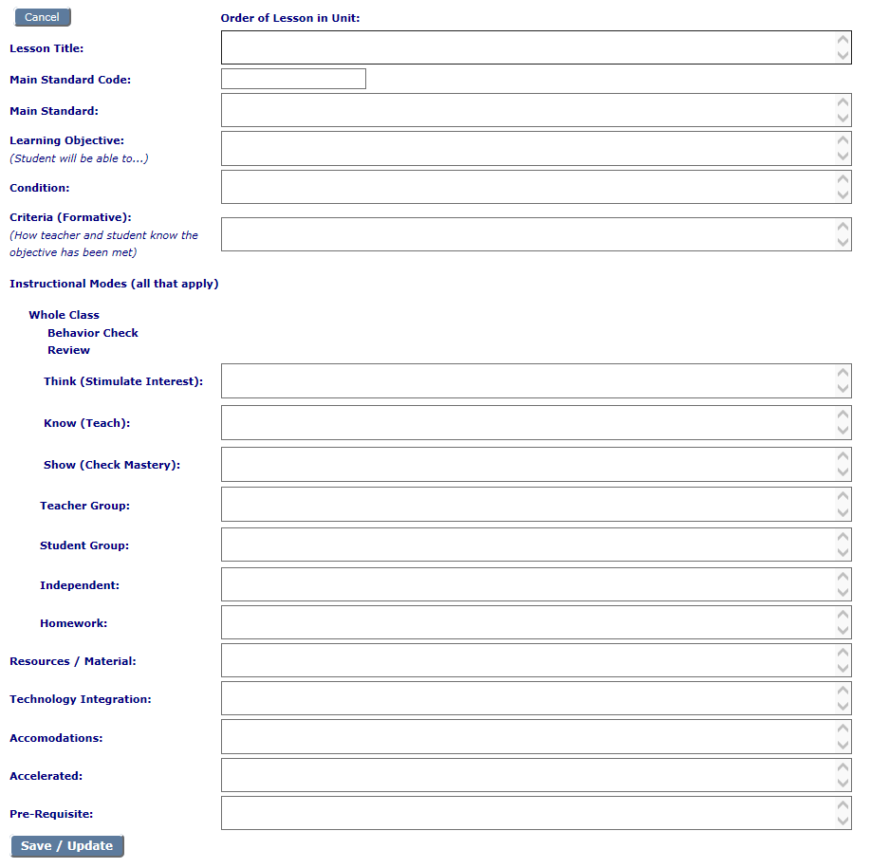

Enhanced Lesson Design
The Basic Lesson Design gives the teacher a roadmap for the week for each course, and when the Basic Lesson Designs are strung together in sequence, the whole school year is illustrated and outlined. The teacher has differentiated the lessons so that students can be reached at different levels of prior mastery. The instructional modes (whole class, small group, independent, and homework) have been varied to include both the presentation of new information and the opportunity to practice and master it.
But every teacher deserves something more than the Basic Lesson Design. Every teacher deserves the thrill of the Super Lesson. The Super Lesson is developed using Enhanced Lesson Design.
In the beginning, the teacher selects from all the daily lessons for a week, one to “enhance.” Later more lessons can be enhanced, as time permits. With the selected daily lesson, the teacher builds a more detailed, robust design for that one lesson. The result is a lesson the teacher loves to teach! A Super Lesson—great for the students and exhilarating for the teacher.
The Enhanced Lesson Design not only provides richer detail to the basic lesson design, it intentionally includes strategies to personalize learning and build students’ personal competencies.
The Enhanced Lesson Design is also created, updated, and shared through the online system.

