Lesson Design Studio

Personalization begins with a well-designed lesson

The Lesson Design Studio is an online platform for creating, editing, sharing, and providing feedback on lesson designs. As a teacher creates lessons, they become available for other teachers in the district to view, provide feedback, and glean instructional ideas. The tool also enables a teacher to organize the lessons in a calendar to form a weekly lesson plan. The Lesson Design Studio is lean, workmanlike, and user friendly.

In the Lesson Design Studio, the teacher:

1. Titles a course for a subject area and grade level.
2. Titles the units within the course.
3. Creates Basic Lesson Designs for each unit.
4. Pegs each lesson to a date to create a Weekly Lesson Plan.
5. Provides feedback on lessons designed by colleagues.
6. Edits lesson designs based on experience and feedback.
7. Uses Enhanced Lesson Design to enhance selected lessons by adding personalization strategies.

Logging In

Before teachers begin creating lessons in the Lesson Design Studio, their district has entered their names in the system and created logins and passwords for them. Teachers are given their logins and passwords at the time they are trained to use Lesson Design Studio.

To login to the Lesson Design Studio, the teacher goes to: http://www.adi.org/eld/Login.aspx

The login screen looks like this:

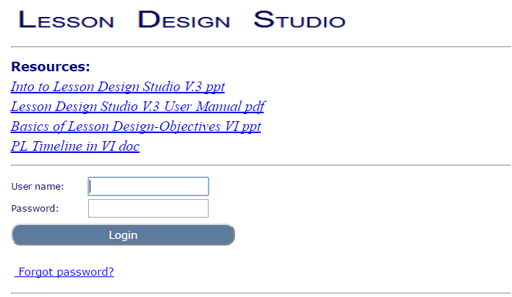

The Menu

The key operations of the Lesson Design Studio are shown on the Menu, and the user selects one to enter into the work areas.

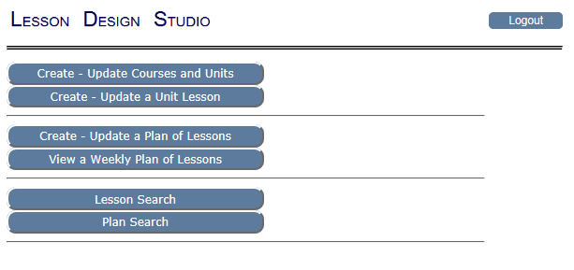

Creating a Course

Selecting the Create-Update Courses and Units bar from the Menu takes the user to a screen that asks the user to select either Create / Edit Courses or Create / Edit Units. Before units can be created, a course must be named to organize the units within.

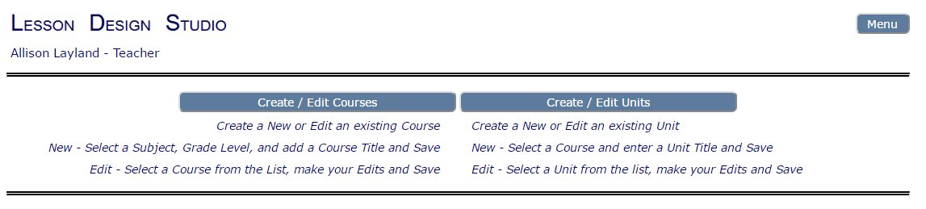

Creating a course is an easy process. Select the subject area from the drop-down menu. Then enter the title of the course. In elementary schools, the subject and course may be the same thing; that is fine. Then select the grade level most appropriate for the course. Some courses are taught across grade levels; just select the one at which the course is primarily targeted.

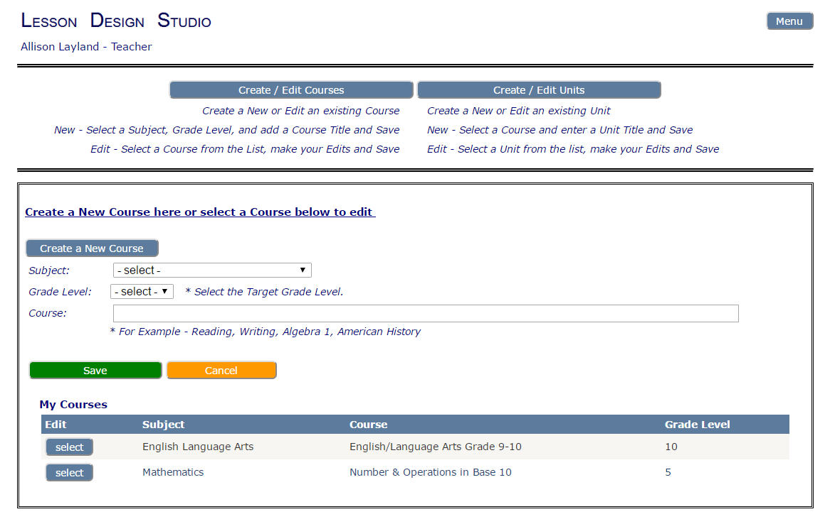
Now save. That’s it. Want to make a change? That’s easy too. Just select the course from the list below and edit.

Creating Units

A course is divided into instructional units. The number of units is determined by district policy, a curriculum guide, or the teacher team or individual teacher. Units are the big chunks of a course—multiple lessons—within an umbrella unit title. Sometimes units correspond with grading periods. Typically a semester course includes two to five units and a year-long course four to 10 units, but again that is locally determined.

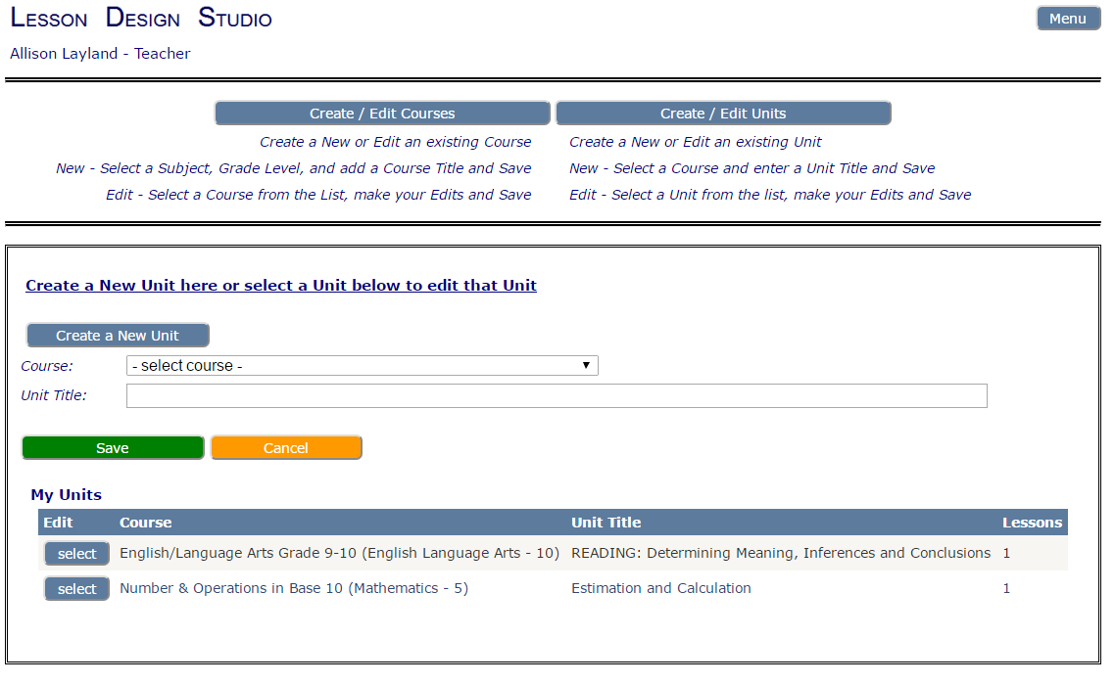

The teacher simply selects the course and then gives each unit in the course a name. The unit will appear below, where it can be edited.

Creating Lessons

Back at the Menu, the teacher selects Create / Update a Unit Lesson. The next screen (below)
asks which course and unit the lessons will be assigned to.

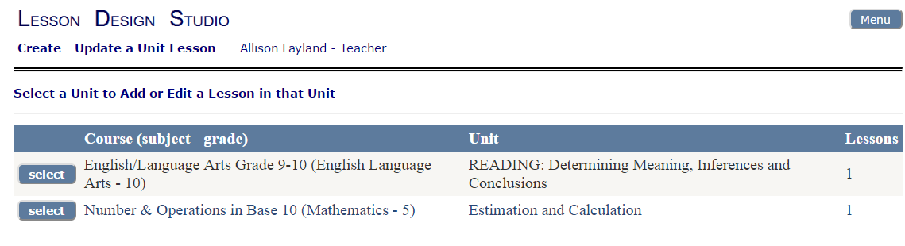

After selecting the course and unit, choose Add a New Lesson to the Unit on the next screen, to begin designing a lesson. The teacher is presented with the template for a Basic Lesson Design. The top portion of the template is the Lesson Definition.

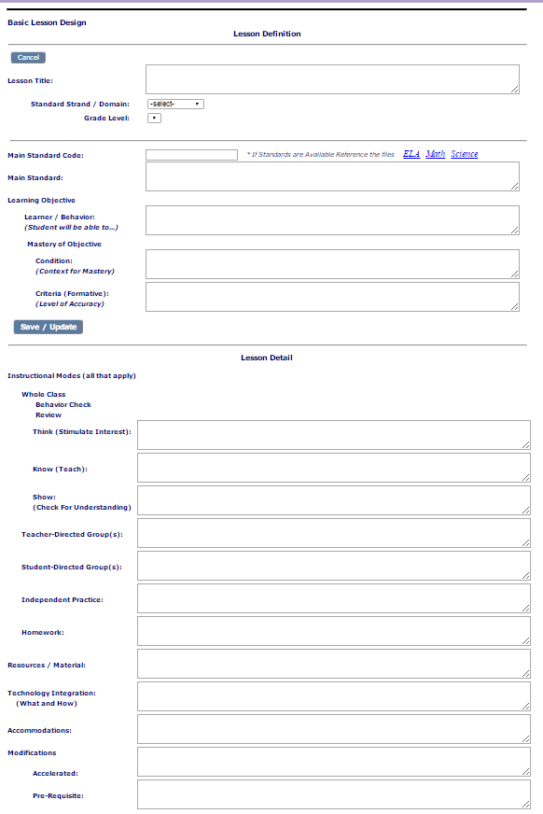

To create a Weekly Lesson Plan by assigning a date to each lesson (see below), the Lesson Definition information must be completed. That is the bare bones of a lesson. The real meat of the Basic Lesson Design is in the lesson detail. Here the teacher enters the information that will enable the teacher to prepare for the lesson and to deliver the instruction in the classroom.

Lesson Definition

Lesson Title: The teacher chooses a title that best fits the topics to be covered in the lesson.

Standard. Select a Main Standard using the two drop-down menus—Standard Strand/Domain and Grade Level. Making these selections will automatically fill the fields for Main Standard Code and Main Standard.

If the standard is not found in the drop-down menus, it may be posted by the Main Standard Code as a PDF to look up and copy.

Main Standard Code: Quite possibly, more than one standard is touched upon in a lesson, but the Basic Lesson Design asks the teacher to select the one standard that will be the primary focus of the lesson and to enter the code for that standard here.

Main Standard: The primary standard addressed in this lesson.

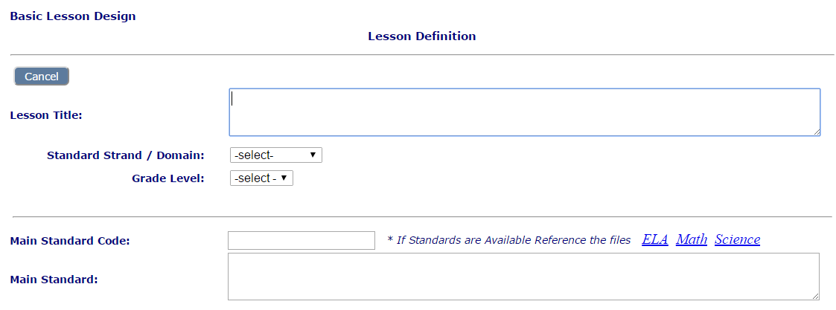

Learning Objective: The learning objective includes the elements below—the learner, the learner’s behavior, and the conditions and criteria for determining when the objective has been mastered.

Learner/Behavior: The learner’s behavior is typically stated as “Student will be able to . . . .”
What knowledge and skill will the student be able to demonstrate behaviorally?

Mastery of Objective

Condition: Under what conditions will students be asked to demonstrate their mastery of the lesson’s objective? For example, “On a worksheet with fraction problems,” or “In a 3- minute presentation to the class.”

Criteria (formative): By what criteria will the teacher and student know that the student has mastered the lesson’s objective? For example, 80% is used in this example: “On a worksheet with fraction problems, the student will correctly answer 80%.” In this example, the criteria is the number of components: “In a 3-minute presentation to the class, the student will utilize all four components of an expository presentation.”

Be sure to click Save/Update to save the lesson definition.

Lesson Detail

The bottom portion of the template is the Lesson Detail.

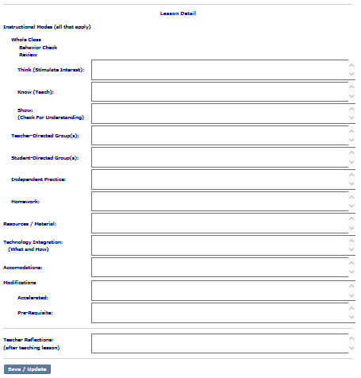

Instructional Modes: The standard modes of instruction are listed below. The teacher will employ at least one mode, and most likely two or more instructional modes during a lesson. In the entry fields, the teacher provides enough information to guide the teacher in conducting the lesson in the classroom and to explain to a colleague what the teacher is doing.

Whole Class: In whole-class instruction, the teacher begins the lesson with a behavior check to be sure all students are attentive and ready. The teacher then reviews the previous lesson and connects it to the current one. In creating the design, the teacher then adds information to the fields that explains the main steps in whole-class instruction:

Think: About 20% of time of the instruction; the teacher stimulates interest in the topic
with “hooks,” advance organizers, brief stories, etc.

Know: About 60% of time of the instruction; the teacher directly teaches the material, interspersed with questioning while maintaining a lively pace.

Show: About 20% of time of the instruction; , the teacher checks for student understanding to both gauge mastery and identify those students who may need other instructional modes (such as a teacher group) or lesson modifications. Teacher could use questioning, choral response, recitation, or other means for students to demonstrate understanding during Show.

Teacher-Directed Group(s): Teacher groups are usually homogeneous groups of students the teacher pulls together because they have a similar instructional need. The groups are fluid, and the teacher forms them as needed to directly teach or reteach. In this field the teacher notes the topic (or topics) that the teacher will address in one or more teacher groups related to this lesson, as well as the activity instructions.

Student-Directed Group(s): Student groups are usually heterogeneous, and the teacher may use cooperative learning techniques. Always, the students need instructions and an end goal or work product to aim for. This information for student groups related to this lesson are entered here.

Independent Practice: The independent practice activity allows each individual student to apply or practice the newly acquired skill(s). The teacher notes the purpose of the independent assignment here and includes any needed student instructions, including how the work will be checked (self-check, peer-check, teacher-check).

Homework: The homework assignment reinforces student learning from the lesson through practice and may provide opportunities for more learning. The activity and any needed student instructions are entered here, including how the work will be checked (self-check, peer-check, teacher-check).
Resources / Materials: The teacher enters the resources and materials that the students and teacher will need throughout all lesson activities, including homework.

Technology Integration: Technology can enhance and personalize learning. The technology tools (hardware or software) used by the teacher or students, if any, are listed here along with its purpose and use.

Accommodations: Accommodations help a student access the lesson without changing the content or skills being taught. For example, a student may need to type his or her responses on a laptop as opposed to writing with pen and paper. The laptop is an accommodation that does not change the expected learning, but allows the student to show his or her understanding in a way that is accessible for that student. What accommodations will be needed for students with disabilities, English learners or students with IEPs?

Modifications: Modifications are changes to either content or skill to meet the needs of students for either accelerated learning or acquisition of pre-requisite skills in order to master the lesson objective.

Accelerated: The modified content and assignments to accelerate learning and keep those students who have already demonstrated mastery of the learning objective engaged should be specified.

Pre-requisite: The modified content and assignments that support students who have not yet mastered the pre-requisite skills or content needed for the new lesson objective, assignments or homework to provide them the building block skill and knowledge development that will enable them to ultimately meet the objective should be specified. How can their assignments be modified to provide them with the building-block skill and knowledge development that will enable them to ultimately meet the objective?

There you go! A Basic Lesson Design has been created.

Creating and Updating a Plan of Lessons

In creating a plan, the teacher simply assigns a date to a lesson. In assigning lessons to each day in a week, a Weekly Lesson Plan is created. Skip days where there is no school or when the course is not meeting.

First select the unit.

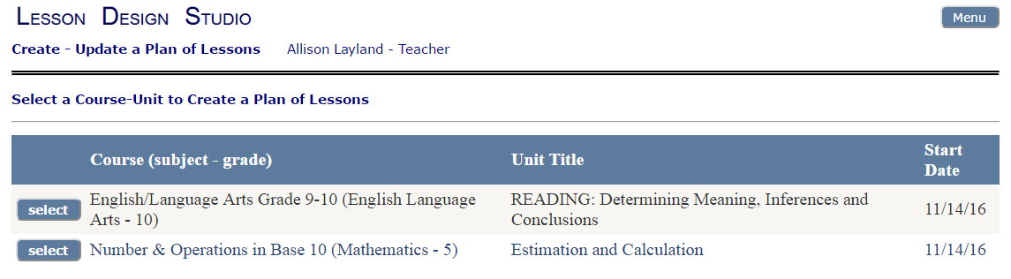

Then add a date for each lesson.

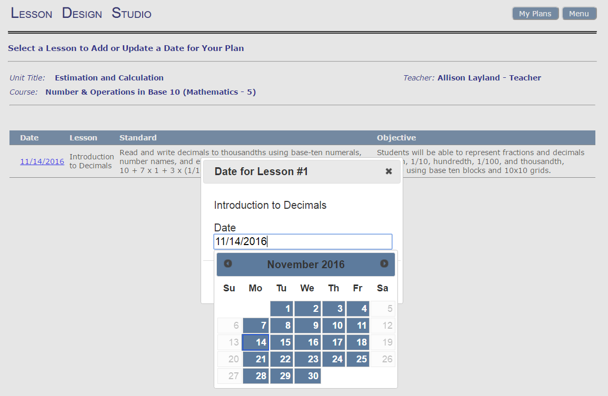

View a Weekly Plan

The Weekly Plan will include all the courses and lessons that the teacher has assigned to a week. Click on a lesson title, and the whole lesson appears!

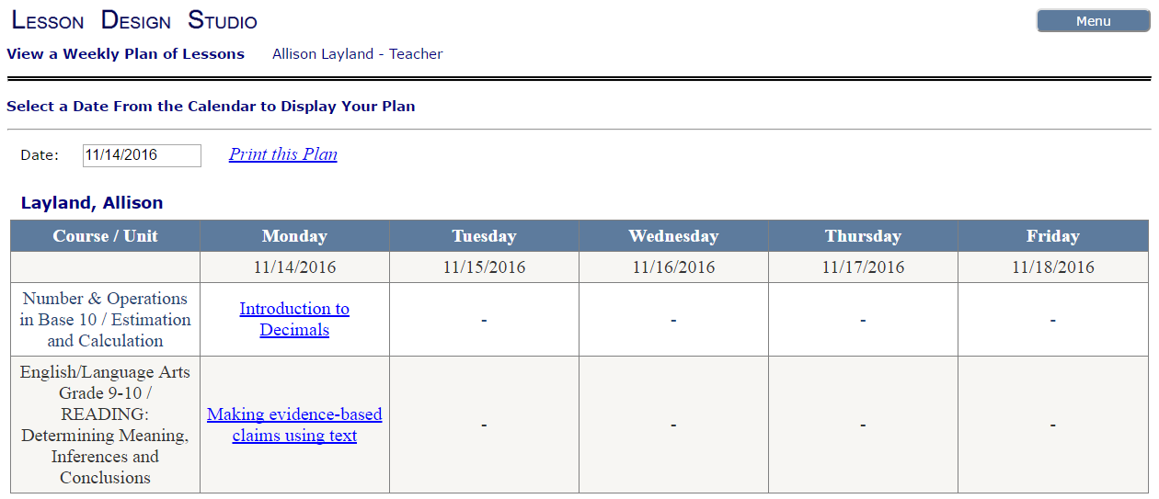

Lesson Search

Any lesson created by a teacher in the district can be viewed (read only) through Lesson Search, and the search fields provide several ways to locate a lesson.

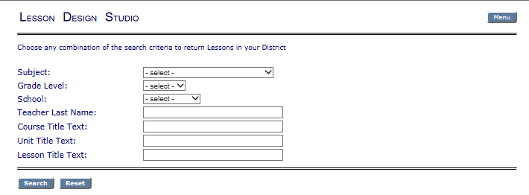

Providing Lesson Feedback

Lesson Search also enables a colleague to provide feedback to a teacher on a created lesson. The lesson opens below the comment box so it can be viewed as comments are being added. In addition, all previous comments are listed below the new comment box. In the example below, the lesson is Introduction to Decimals. The lesson can be also be saved and printed from this screen as well.

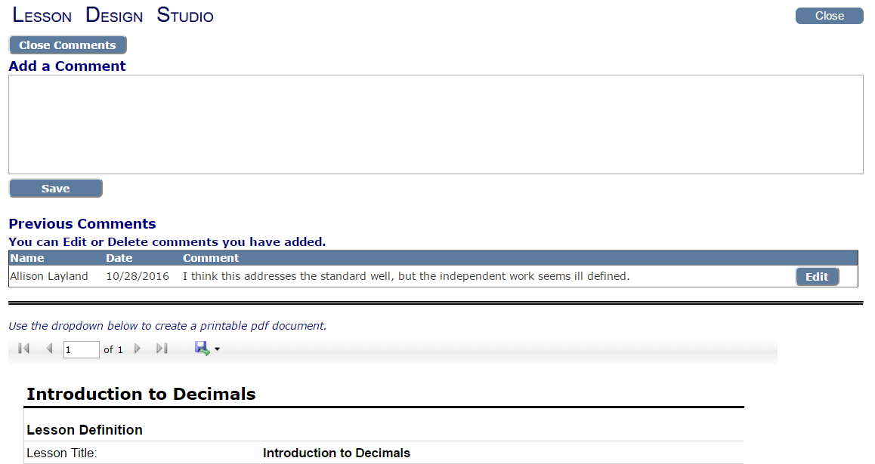

Plan Search

In the Plan Search feature, accessed from the Menu, any teacher’s weekly plan may be viewed by searching for a school, month, and year, then selecting a teacher’s name and a week. Each lesson can then be viewed through the Weekly Plan.

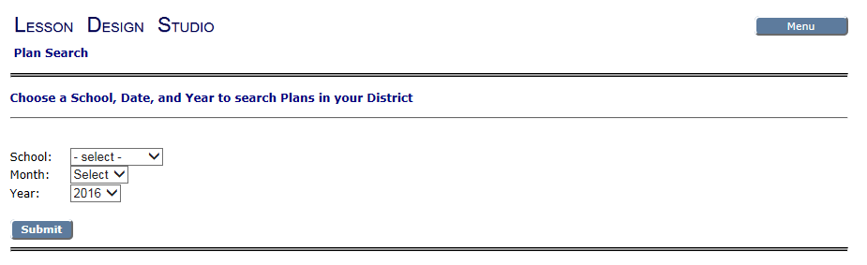

This concludes instructions for the Basic Lesson Design in Lesson Design Studio. Next, the teacher will be ready to select a few lessons and enhance them in Enhanced Lesson Design!

