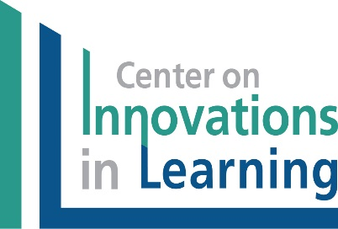


Student-Focused Learning Institute
AGENDA
November 7-8, 2016
EAST Initiative Conference Room
6215 Ranch Dr.
Little Rock, AR 72223

South Central Comprehensive Center (SC3)
and the Center on Innovations in Learning (CIL)

Participant Goals
Participants will demonstrate a greater understanding of Student-Focused Learning, including its components: competency-based education, learning technologies, and personal competencies, and how these support the ADE’s goal of Student-Focused Learning.
Participants will become familiar with the Student-Focused Learning (Personalized Learning) resources supported by the Center on Innovations in Learning (CIL), which could be used to increase knowledge about Student-Focused Learning for ADE personnel and to provide this knowledge to districts and schools in support of implementation.

Monday, November 7, 2016

8:00 a.m. Opening
      - Welcome and Introductions,
Kerri White and Jennifer Watson, SC3
Commissioner Johnny Key, ADE
      - Agenda overview and orientation, Janet Twyman, CIL

9:00–10:00 What Is Student-Focused Learning? Mark Williams, CIL
- What is Student-Focused Learning?
- CIL Perspectives on Student-Focused Learning (three areas)

10:00–10:15 Break

10:15–11:00 Keeping Student Focused: Competency-Based Education (CBE),
Janet Twyman
      - What is CBE?
      - Critical Features of CBE

11:00–11:30 PL & CBE: Policy Implications and Implementation Considerations Facilitators: Kerri White, Jennifer Watson, Mark Williams, Janet Twyman
Questions Generated at Small Table Group Discussion

11:30-12:15 Report Out of Small Groups/Capture Discussion Points
Facilitators: Kerri White, Jennifer Watson, Mark Williams, Janet Twyman

12:15-1:15 Lunch

1:15–2:15 Personal Competencies, Mark Williams
- Cognitive
- Metacognitive
- Motivational
- Social Emotional

2:15-2:30 Break

2:30-3:15 Learning Technologies that Support Student-Focused Learning
Janet Twyman

3:15-3:45 p.m. Recap/Q&A/Plan for Day 2
Kerri White

Tuesday, November 8, 2016

8:00 a.m. Welcome Back and Plan for the Day
Kerri White

8:15-8:45 Innovation Science and Small/Large Scale Change
Janet Twyman

8:45-9:30 Facilitating Student-Focused Learning through Basic Lesson Design
Mark Williams and Janet Twyman

9:30-10:15 Classroom Strategies to Enhance Personal Competencies
Mark Williams

10:15 Break

10:30-11:45 Student-Focused Learning through Enhanced Lesson Design
Mark Williams

11:45-12:45 Lunch

12:45 -1:15 Student-Focused Learning as Part of Arkansas Strategic Planning
Facilitators: Kerri White, Jennifer Watson, Mark Williams, Janet Twyman
Whole group discussion about considerations at the:
- State/District Level
- School/Classroom/Student Level

1:15-2:15 Small Group Breakout: How Does This Affect Our Plans and Work?
Facilitator: Kerri White

2:15-2:30 Break

2:30-3:00 Report out of Small Groups
Facilitators: Kerri White, Jennifer Watson, Janet Twyman, Mark Williams

3:00 -3:30 Recap/Q&A
Next Steps: SC3 and CIL

3:30 p.m. Adjourn

